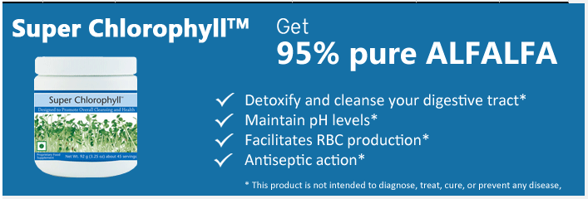
Product Information
A key ingredient in Super Chlorophyll is chlorophyll from the alfalfa plant. Alfalfa has been used for centuries by various cultures as a vitalizing and cleansing agent, and science has recently confirmed the potential health bene t of chlorophyll supplementation. Your skin is the largest organ in your body and is the first barrier to protecting yourself from damaging free radicals. Free radicals speed up the aging process and harm healthy cells, making skin appear wrinkled, dry, and discolored. For decades, many cultures have used chlorophyll to heal and revitalize damaged skin. Studies have revealed that Chlorophyllin—the common form of chlorophyll found in supplements—acts as a powerful antioxidant and internal deodorizer.

How Chlorophyll makes life better
Chlorophyll – Detox agent – by reducing the oxidative stress. Indications – Pollution, UV/EM radiation, Smoking, Alcohol, Inflammation
Chlorophyll – Cleanses by hydrating and maintaining right PH balance improving smoothness of skin. Indications – Hyperacidity, irregular meals, stress, wrinkles, dry skin
Enriches – facilitates RBC production – oxygen in the blood – active & increased metabolism. Indications – Anemia, constipation
Heals – antiseptic action – hastens wound healing – Indications - Diabetic foot ulcers, injuries etc.,
Chlorophyll breaks down CO2 and releases O2. Indications – Body odor, halitosis.

Its benefits include:
Shown to be an effective antioxidant in research studies
May help regulate bowel function
Commonly used as a deodorizer for the intestinal and urinary tract
Acts as an alkalizing agent to maintain pH levels
Used to help beautify and keep skin vibrant and young
Chlorophyllin has been shown to protect DNA from known mutagens
Has been used to heal wounds
Used by individuals as an alkalizing agent to maintain pH levels and whole- body well being
The Remedial Effects of Chlorophyll
“When you are green inside, you are clean inside”

¦Counteracts Toxins Eaten
¦Improves Anemic Conditions
¦Cleans and Deodorizes Bowel
¦Cleans Tooth & Gums Structure in Pyorrhea
¦Lessens Need for Underarm Deodorizer
¦Makes Excellent Tooth Surgery Gargle
¦Revitalizes Vascular System in the Legs
¦Reduces Pain Caused by Inflammation
¦Aids Hemophilia Condition
¦Aid in Asthma Improvement
¦Increases Iron Content in Milk
¦Improves Milk Production
¦Improves Nasal Drainage
¦Slows Nasal Drip
¦Eliminates Bad Breath
¦Builds a High Blood Count
¦Improves Blood Sugar Problems (Diabetes)
¦Provides Iron to Organs
¦Helps Purify the Liver
¦Aids Hepatitis Improvement
¦Feeds Heart Tissues Iron
¦Regulates Menstruation
¦Resists Bacteria in Wounds
¦Soothes Ulcer Tissues
¦Soothes Painful Hemorrhoids and Piles
¦Aids Catarrhal Discharge
¦Improves Varicose Veins
¦Eliminates Body Odors
¦Relieves Sore Throat
¦Benefits Inflamed Tonsils

Also Helpful in :

Super Chlorophyll can be taken for general health improvement, it's a great pH balancer to detoxify our body which is made acidic by our regular foods and bad life style.
Keeping our blood to be clean is the main and foremost thing to be away from all ailments. SC will purify our blood to increase our metabolism.
"The healing power of Chlorophyll" wrote some of its efficacies as follows:

1. Inhibits bacterial growth

2. Improves Oral health

3. Improves heart function

4. Eliminate body odour

5. Alleviates ladies ailments

6. Balances Acid and Alkaline Level in body.

7. Increase Red Blood Cells.

8. Improves Anemic condition.

9. Soothes sore throat

10. Reduces Asthmatic problems.

11. Relieves joints and backbone problems

12. Improves Urinary tract system

13. Enhances Blood circulation

14. Delays ageing process.

15. Abates digestive problems

16. Purifies blood

17. Provides Iron to organ

18. Detoxifies blood and acts as anti-cancer.

19. Improves Cell Function

20. Accelerates healing of wounds

21. Reduces inflammation.

22. Enhances Lung infection.

23. Abates the risks of Bronchitis

24. Improves functions of Thyroid Glands

25. Enhances Metabolism

26. Strengthens Immune system

27. Stabilize body temperature

28. Relieves Insomnia problem

29. Alleviates pain.

30. Improves Liver function.

31. Improves Kidney function

32. Improves Urinary tract functions. Other Usage Benefits:

o It can be applied on the cuts and scratches as a first aid lotion.

o It can be used as after shave lotion.

o It can be used as Mouth Wash. o It can be used on the scalp for better hair growth, and preventing dandruff. o It can be kept inside the fridge o It can be given to pets for better health

